Intercultural Pedagogy Practice: A Scottish Teacher’s Experience with Vietnamese and Indonesian EFL Learners Online
Safrina Hulu^{1*}, Ni Nyoman Padmadewi², I Gede Budasi³
^{1,2,3}Universitas Pendidikan Ganesha
*Corresponding author: safrinahulu28@gmail.com
ARTICLE INFO
Article history  Received April 3, 2026  Revisied April 25, 2026  Accepted May 5, 2026 |  | ABSTRACT  This study explores the role of a teacher's instructional beliefs and intrinsic motivational orientations in facilitating culturally mediated online English as a Foreign Language (EFL) learning. The research focuses on a Scottish teacher voluntarily conducting online English lessons for Vietnamese and Indonesian students using synchronous and asynchronous tools. Guided Self-Determination Theory encompassing competence, relatedness, and autonomy, this qualitative case study collected data through interviews, classroom observations, and analysis of student communications and learning materials. Findings reveal that the teacher's altruistic motivation shapes a learning approach centered on intelligibility-oriented pronunciation, reading guidance, and emotional encouragement, thereby enhancing students' self-confidence and motivation. Student autonomy was supported indirectly through a structured learning approach that aligned with their cultural preference for direct instruction and correction. These findings underscore the significance of a teacher's belief system and motivational orientations in facilitating effective online EFL learning across diverse cultural backgrounds.
Keywords: Cross-cultural online learning, Culturally responsive teaching, Learner engagement, Self-Determination Theory, Teacher motivational beliefs

INTRODUCTION
The integration of digital technologies in the teaching of English as a Foreign Language has revolutionized the process of teaching and learning, allowing for the facilitation of cross-border interactions and the expansion of the accessibility of English education globally. The use of technology has been a major focus of research, particularly in relation to the accessibility of platforms, the efficacy of technology in the teaching of English as a foreign language, and the use of digital tools in the teaching process (Cheng & Tsai, 2019; Russell et al., 2003). However, recent studies indicate that technology alone does not ensure effective learning, as instructional quality depends largely on how teachers structure interaction and mediate learning processes in online environments (Tao & Gao, 2022; Moorhouse et al., 2022). Furthermore, technological disruptions may negatively affect learners’ willingness to communicate, particularly in speaking-oriented tasks (Peng et al., 2023). There has been limited focus on the role of the human factors in the teaching of English as a foreign language. Specifically, there has been limited research on the role of the teacher’s pedagogical beliefs and motivational factors in the teaching of English as a foreign language in the context of intercultural online teaching. This is important for a number of reasons. Pedagogical beliefs of the teacher have a major role to play in the teaching of English as a foreign language, particularly in the context of classroom interactions, teacher-student feedback, and the overall process of teaching (Cementina, 2019; N. Nguyen & Williams, 2016; Waluyo & Apridayani, 2021). In the context of the online classroom, where communication is highly dependent on the teacher’s ability to communicate effectively, the role of the teacher’s pedagogical beliefs is more significant. The role of teacher motivation is also important. Although there has been some focus on the role of teacher self-efficacy in the teaching of English as a foreign language, there has been limited focus on the role of intrinsic and value-based motivations in the teaching of English as a foreign language, particularly in the context of the online classroom. Recent research suggests that teacher motivation is dynamically shaped through interaction and directly influences instructional engagement and decision-making in online contexts (Guay, 2021; Jeon & Lee, 2023). Another factor that complicates cultural responsiveness in online EFL instruction is that an effective pedagogy requires an understanding of learners’ expectations of teacher authority, feedback, and organization of instruction (Kuru Gönen, 2019; Pham & Renshaw, 2015). For example, learners from Southeast Asian countries might expect structured instruction, explicit correction, and teacher presence, which might be different from what is emphasized in Western pedagogies, which stress autonomy (Blignaut et al., 2010; Jiang et al., 2021). Although the impact of culture on learning has been recognized, there is limited research on the relationship between teachers’ instructional philosophy, motivational style, and learners’ culturally shaped expectations in online contexts (Phuong, 2020). Such a relationship is particularly relevant to online instruction, as cultural differences might be more visible because of the lack of a shared physical environment.
Another factor that influences online EFL instruction in Southeast Asia is the technological infrastructure used for instruction. Skype and WhatsApp are commonly used platforms for online instruction, given their availability and affordability (Tao & Gao, 2022). Nonetheless, technical disruptions are common, which might be frustrating for both teachers and learners (Hambira et al., 2017; Maru et al., 2021; Peng et al., 2023). Such disruptions may interrupt interactional flow and reduce learner participation, particularly in communicative activities (Peng et al., 2023). Although, technology is essential for communication, it does not guarantee effective instruction. Rather, it is the teachers’ instructional philosophy that influences the use of technology for instruction. The Southeast Asian online EFL context is an interesting setting for exploring the relationship between teachers' instructional philosophy, interactional style, and learners' engagement (Moorhouse et al., 2022; Ngo, 2022), particularly as learners’ expectations change with exposure to global communication styles (Sim & Ismail, 2023). However, there remain some crucial gaps in our understanding. Firstly, prior research tends to examine technology and teacher beliefs separately, with limited attention to how belief systems interact with intrinsic motivation in shaping online pedagogical practices (Guay, 2021; Jeon & Lee, 2023). Secondly, most studies are situated in institutional contexts, leaving voluntary and non-commercial online teaching underexplored (Tao & Gao, 2022). Thirdly, there is insufficient research on how learner cultural expectations intersect with teachers’ motivational approaches and instructional practices in real-time online interaction, particularly under technological constraints (Moorhouse et al., 2022; Peng et al., 2023). This creates uncertainty with regard to how concepts such as autonomy support, structure, and emotional encouragement are interpreted. This study attempts to fill these gaps by highlighting the relational, motivational, and cultural aspects of online EFL teaching. In this context, this study aims to explore the relationship between teacher beliefs, intrinsic motivation, pedagogical approaches, and learner cultural factors in an online EFL context. This study examines the relationship in an online EFL context where there is a Scottish teacher involved in voluntary online EFL teaching with Vietnamese and Indonesian learners. The research question is: How does a teacher’s motivational philosophy and instructional beliefs come into play in an online EFL context, and how do learners from different cultural backgrounds respond to it? This study aims to explore how (1) intrinsic motivation plays a role in pedagogical decision-making, (2) instructional approaches reflect culturally responsive teaching, and (3) learners respond to structured approaches, pronunciation support, and affective encouragement in an online EFL context. Data sources for this study include teacher interviews, observations of online instructional interactions, and learner-produced materials. By highlighting the human and cultural aspects of virtual teaching, this study adds to a more comprehensive understanding of cross-cultural virtual EFL education. The study shows that online EFL teaching is not only mediated by technology, but also by the teacher’s belief systems, motivational commitments, and relational approaches. The study’s results have implications for teacher training, especially in relation to preparing EFL teachers for intercultural virtual spaces that demand motivational and pedagogical flexibility.To address these concerns, this study specifically examines how a teacher’s motivational philosophy and instructional beliefs operate in an online EFL context and how learners from different cultural backgrounds respond to these practices. The findings presented in the Results and Discussion sections are organized in relation to these research questions. The rest of this article is structured as follows. The next section briefly discusses the relevant theory of teacher beliefs, intrinsic motivation, and cultural pedagogy. The methodology section briefly explains the qualitative case study approach and analytical strategy. The findings section discusses the results in relation to teacher motivation, pedagogy, and learners, and links these results to the broader debates in online EFL teaching. The article concludes with implications and suggestions for future research.

METHODS
This study used a qualitative single-case study research design to explore the influences of the teacher’s beliefs, intrinsic motivation, and practices on intercultural online English as a Foreign Language (EFL) learning. The reason for the choice of the qualitative approach was that intercultural online EFL learning is a socially constructed phenomenon that is full of emotions and culturally mediated interactions that cannot be captured through quantitative methods (Chen et al., 2021; Hasanah & Abdulrahman, 2021; P. Wang, 2022; Yuan & Yang, 2023). The choice of the single-case research design allowed for an in-depth and holistic investigation of a naturally occurring setting where the teacher’s instruction, motivation, and intercultural communication come into play (Arellano et al., 2001; Phillips, 2021; Zhang & Martinovic, 2009). This research design was scientifically appropriate for the close scrutiny of the relational and instructional processes that occur in their natural context. The target population for the study was the Scottish teacher who was engaged in the voluntary online English instruction and the 22 Vietnamese and Indonesian learners who were the recipients of the intercultural online EFL instruction. The context of the study was the long-term voluntary online English instruction that connected the Scottish teacher with the Southeast Asian learners. The instruction was synchronous through the Skype platform and asynchronous through the WhatsApp platform. Both of these online platforms are commonly used in the context of under-resourced educational settings due to their ease of access and low technological demands (Tao & Gao, 2022). The unit of analysis was the teacher-learner interactional process. Purposeful sampling was used to identify an information-rich case with high intercultural teaching experience (Li et al., 2024; Omona, 2013). The participant of interest was a Scottish male teacher with 18 years of voluntary online teaching experience. The students he worked with consisted of 22 Vietnamese and Indonesian EFL learners who actively participated in the online lessons. The EFL students were from a cross-border educational tradition where the role of the teacher was traditionally emphasized as a guide with an important presence (Blignaut et al., 2010; Kuru Gönen, 2019). The target and realized sample size consisted of one teacher and one intact group of learners, as the case study was bounded. No questionnaires were required as the design of the study was qualitative and focused on interactions.
In this study, multiple qualitative approaches were used to collect the required data to increase the triangulation and credibility of the research (Kerwin-Boudreau & Butler-Kisber, 2016; Poth, 2018). The first method of data collection involved conducting semi-structured interviews with the teacher about his beliefs about teaching, motivational orientations, and his experience with intercultural online teaching (Fenyi et al., 2020; T. P. D. Nguyen & Nguyen, 2020). The second method of collecting the required data involved online observations of the teacher and his instructional strategies, including his pronunciation strategies, reading strategies, feedback mechanisms, and teacher-student rapport (Fenyi et al., 2020; T. P. D. Nguyen & Nguyen, 2020). The third method of collecting the required data involved collecting the WhatsApp messages and learning materials of the EFL students to identify their engagement with the teacher and the learning materials. The data analysis used thematic analysis, assisted by NVivo, which helped in the systematic organization and coding of the qualitative data (Hidson, 2020; Hur et al., 2020). The use of NVivo helped in transparency, as it allowed tracing the coded data back to the source (Bonello & Meehan, 2019). The data analysis used an iterative inductive-deductive approach (Maher et al., 2018; Wong, 2008). The process began with data familiarization, whereby data such as transcripts, observation records, and digital communications were repeatedly studied to acquire an overall understanding of instructional philosophy and learner interaction patterns. Reflexive memos recorded ideas that began to surface with respect to teacher motivation, pronunciation, reading, and emotional support (Kuş Saillard, 2011; Palys & Atchison, 2012). Following this, open coding involved inductive coding of significant data segments that described teacher approaches, motivational statements, and learner responses (Maher et al., 2018; Palys & Atchison, 2012; Welsh, 2002). Codes were descriptive and based on data participants’ language. The next step involved axial coding, where similar codes were combined to create more general conceptual categories. For instance, codes such as “teaching without payment” and “personal satisfaction from student progress” combined to create the category Teacher Intrinsic Motivation and Altruism. Codes associated with pronunciation correction and reading fluency combined to create the category Intelligibility-Oriented Pedagogy, whereas praise and reassurance combined to create the category Affective and Relational Support. NVivo’s visual tools facilitated constant comparison of data from multiple sources, including interviews, observations, and learner messages (Bandara et al., 2015; Bryda & Costa, 2023).
In the last stage, the categories were synthesized into overarching themes, which were Altruism and Motivation, Pedagogical Focus on Intelligibility and Structure, Online Teaching Challenges and Adaptation, Student Psychological Management, and Advocacy for Quality Teaching. The development of themes was an iterative process of constant movement between the raw data, the coded data, and the conceptual interpretation of the data, in order to ensure empirical and conceptual integrity, respectively (Feng & Behar-Horenstein, 2019; Hur et al., 2020). NVivo was helpful in retrieving the supporting data excerpts in an efficient manner (Hidson, 2020). In order to ensure trustworthiness, data triangulation was employed, where the teacher interviews, observations, and communications were compared and contrasted (Poth, 2018). Dependability was ensured through memoing and constant revision of the codes, which is a common practice in qualitative research (Kuş Saillard, 2011; Palys & Atchison, 2012). The combination of interpretation and NVivo coding ensured a high level of methodological rigor, which is a requirement in qualitative research ((Bandara et al., 2015; Bryda & Costa, 2023; Welsh, 2002). Finally, interpretation was informed by Self-Determination Theory and Culturally Responsive Teaching, which provided a conceptual framework to understand the role of teaching in responding to learners' needs for competence, relatedness, and cultural meaningfulness. This inductive and interpretive approach provided a nuanced understanding of the interplay between teacher beliefs, motivation, and pedagogy, and learners' cultural expectations in an online EFL teaching context.
Integrated Qualitative Analysis and Thematic Framework
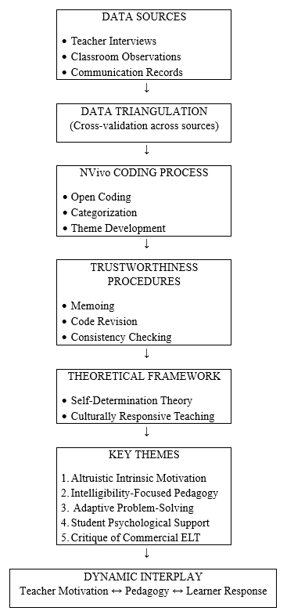

RESULTS AND DISCUSSION

RESULTS
Several prominent patterns are identified in Mr. Tony’s long-term voluntary English teaching practice by means of qualitative thematic analysis with NVivo coding software support. The research results reported in this paper are focused primarily on the most prominent themes that are directly relevant to teacher motivation, pedagogical concerns, problem-solving, and psychology. All interpretations are informed by coding segments of interview data, as opposed to anecdotal evidence. One of the prominent research results is that Mr. Tony’s English teaching practice is primarily sustained by his intrinsic and altruistic motivation, as opposed to being supported by a reward system. This result contrasts with dominant research paradigms of teacher motivation, which balance intrinsic values with institutional or monetary rewards. This study shows a complete lack of monetary compensation for his services over an 18-year period, as evidenced by his interview statements, which suggest that student progress serves as a psychological non-monetary reward mechanism to replace monetary motivation. The high frequency of coding segments under Non-monetary Reward and Motivation from Students’ Dedication implies that emotional reciprocity between teacher and student creates a non-monetary reward cycle, which contrasts with previous research on teacher motivation that did not find this phenomenon. This study also contrasts with previous research on teacher retention, which emphasized structural support for long-term teacher engagement, by highlighting his mission-driven identity, which is informed by his altruistic motivation for social contribution. What is unexpected is that his unpaid engagement does not display burnout symptoms, which contradicts dominant research paradigms in teacher sustainability research. A second important discovery relates to pedagogical orientation. Mr. Tony always gives priority to the clarity of speech and the intelligibility of the written word rather than the mastery of grammar. High coding frequencies in the categories of Reading Mechanics and Word Endings reveal a strong focus on the systematic teaching of phonological closure, pauses, and speech rhythm. Mr. Tony does not follow the conventional English as a Foreign Language teaching models commonly applied in Asia, where grammar accuracy is considered a priority. Instead, he views grammar as a secondary issue compared to the comprehensibility of the utterance. This is a functional communicative model in which pronunciation is considered a protective mechanism in the event of future social or professional misunderstanding. The unexpected discovery is the teacher's claim that complex grammar is not needed in communication, which is in sharp contrast to the conventional educational paradigms in Asia, where exam results determine educational success. This discovery relates to the teacher's pedagogical belief system, which is closer to the intelligibility-based model of pronunciation studies than to the conventional grammar-based model of language teaching.
A second major discovery relates to the ways in which the challenges of voluntary online teaching are addressed through self-developed solutions rather than through the infrastructure of the institution. High coding frequencies in the categories of Material Selection & Leveling and Self-Developed Resources reveal a strong link between the problem and the solution. The teacher identifies learner heterogeneity as a key issue in teaching, which is addressed through the independent development of a website to organize the leveled materials. This discovery is important in that it reveals a high level of pedagogical agency and technology self-efficacy, which is different from the conventional literature on the difficulties faced by older teachers in technology adoption. The transition from PalTalk to Skype to Microsoft Teams is a clear indication of the teacher's adaptation to technology, which is often viewed as a barrier to teaching. Another finding is the prominence of student psychological management. The references categorized under Praise and Encouragement and Overcoming Anxiety reveal the teacher’s strategy of avoiding negative evaluation. Instead of feedback in the form of error identification, he uses praise to manage affective filters. This finding supports the affective filter hypothesis of language learning and extends it by showing the role of praise in anxiety management. What is also noteworthy is that the teacher’s approach shows that building students’ confidence is a prerequisite for building fluency. What is surprising is the finding that there is a near-absence of criticism in the teacher’s feedback philosophy, which is in contrast to the balanced feedback approach advocated in teacher training literature. Finally, the findings reveal a strong ethical critique of profit-based language teaching systems. The references categorized under Critique of Commercial Centers reveal the teacher’s repeated assertion of the negative impact of financial motives on teaching quality. This finding reinforces the previous finding of altruistic identity and shows that the teacher’s teaching approach is linked to a broader social philosophy of access to education. What is noteworthy is that this approach is in contrast to market-based approaches to language teaching. What is surprising is that this finding is rarely foregrounded in empirical studies of ELT. It is a distinctive feature of this study.
  - Altruism and Motivation (The "Heart Call")

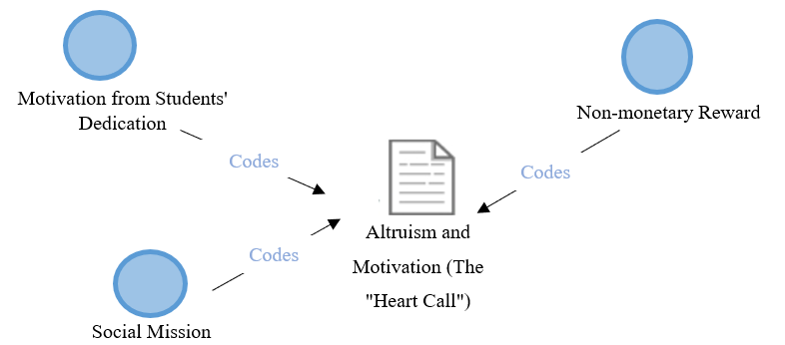
This theme covers the teacher's internal drive to teach for 18 years without financial compensation. Motivation from Students' Dedication (Q3): "My motivation was the children's motivation. Really. They were determined to learn and their parents were determined to learn. They just turned up every week and they gave me 100%." Non-monetary Reward (Q4): "I don't want payment... When I hear the children reading better and speaking better, that's my payment. That's worth more than any money." Social Mission (Q8): "People want money, money, money, money. They want to make money. I don't do that... My goal in life is not to make money from people." Mr. Tony’s 18-year journey in voluntary teaching is rooted in a profound sense of altruism and intrinsic motivation. According to the interview, his drive is fueled by a symbiotic relationship with his students; he notes that "my motivation was the children's motivation," observing that both the students and their parents "gave me 100%" effort every week. Unlike commercial educators, he rejects financial compensation, explicitly stating, "I don't want payment." For him, the true reward is witnessing the linguistic growth and future success of the children, which he considers "worth more than any money." This perspective serves as a critique of the broader educational landscape where many are driven by profit, as he maintains that his primary "goal in life is not to make money from people."
  - Pedagogical Focus
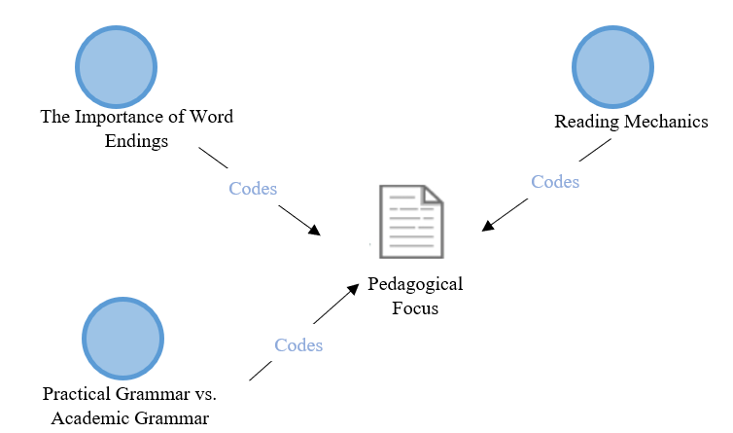
This theme highlights the teacher’s priority on "real-world" clarity over academic rules. The Importance of Word Endings (Q1 & Q6): "I mostly did pronunciation at the end of a word with them because it was at the end of a word." "You need to tell them the end of the word. Because in later days... someone's going to say... Did your teacher teach you? Yes, he never told us the word. Wrong. You need to know right from the start." Reading Mechanics (Q7): "I'm talking about taking a slight pause after a comma and stopping after a full stop. ... Don't rush your time. More important to say the end of the words... than it is to be quick." Practical Grammar vs. Academic Grammar (Q7.1 & Q8): "For everyday life, like I'm talking about British people, for everyday life, we don't use a lot of grammar. We just don't. We don't need it." In terms of pedagogy, Mr. Tony prioritizes "real-world" clarity and phonological awareness over rigid academic rules. He places heavy emphasis on pronunciation, specifically "at the end of a word," arguing that students must learn this "right from the start" to avoid future professional embarrassment. His teaching of reading mechanics involves practical techniques such as "taking a slight pause after a comma and stopping after a full stop," prioritizing accuracy over speed. Furthermore, he challenges the heavy emphasis on grammar common in Asian educational contexts, suggesting that "for everyday life... we don't use a lot of grammar," and posits that complex grammar is only a necessity for those pursuing specific careers like teaching.
  - Online Teaching Challenges and Solutions

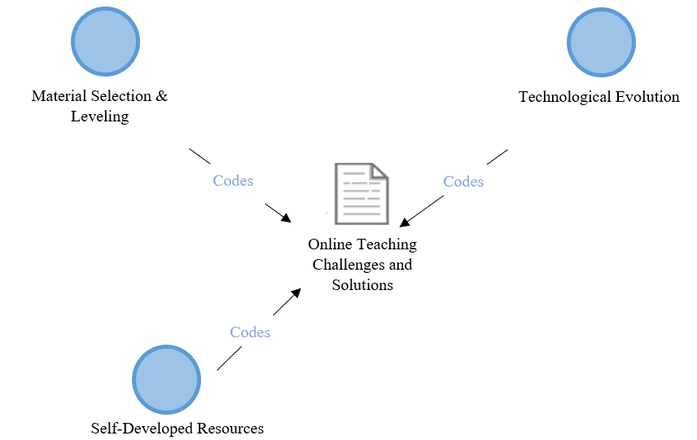
This theme covers the technical and logistical hurdles of voluntary online education. Material Selection & Leveling (Q9 & Q10): "Some of the challenges would be getting the right reading for the right student. Like if someone was four or five and someone was 12. It's getting them to get the right story for them to read." "You get to know them as individuals. Remember, they're not all just students. They're all individuals." Technological Evolution (Q2): "I did it in a room on PalTalk whereas on Skype I usually do it individually. ... They've got a thing called Microsoft Teams which is taking over for Skype." Self-Developed Resources (Q5): "I made a little website... with different materials. It wasn't for myself. It was for the kids to see... I didn't know how to make a website. I made one. I figured it out." The study highlights several technical and logistical hurdles inherent in voluntary online education and Mr. Tony’s proactive solutions. He identifies "getting the right reading for the right student" as a primary challenge, emphasizing the need to treat students as "individuals" rather than a monolithic group. To solve the issue of resource accessibility, he demonstrated self-reliance by building a dedicated website for materials, stating, "I didn't know how to make a website. I made one. I figured it out." Additionally, his experience reflects the rapid evolution of technology, moving from PalTalk to Skype, and now preparing for the transition to Microsoft Teams, showing a continuous need for digital adaptation in the virtual classroom.
  - Student Psychological Management
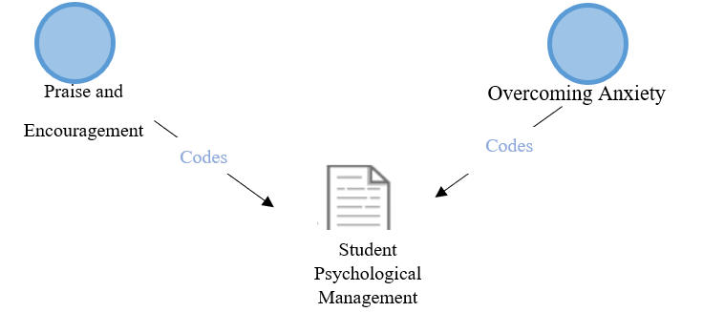
How the teacher builds confidence and reduces anxiety in a virtual classroom. Praise and Encouragement (Q11): "I don't ever tell a student that was bad. ... If you tell someone that was very good today, well done. Give them praise. And they get more confident." Overcoming Anxiety (Q11): "I get to know them very quickly. ... I know everybody's going to be nervous at first. But after a while, they lose that. Then they'll come on and they'll read." A critical finding of this research is Mr. Tony’s humanistic approach to managing student anxiety and building confidence. He utilizes a strategy of consistent positive reinforcement, asserting, "I don't ever tell a student that was bad." By focusing on "praise" rather than correction, he helps students overcome the initial nervousness that often hinders language acquisition. He notes that while "everybody's going to be nervous at first," getting to know the students personally allows them to "lose that" anxiety. This supportive environment ensures that students feel safe enough to practice and eventually read fluently without the paralyzing fear of making mistakes.
  - Advocacy for Quality Teaching
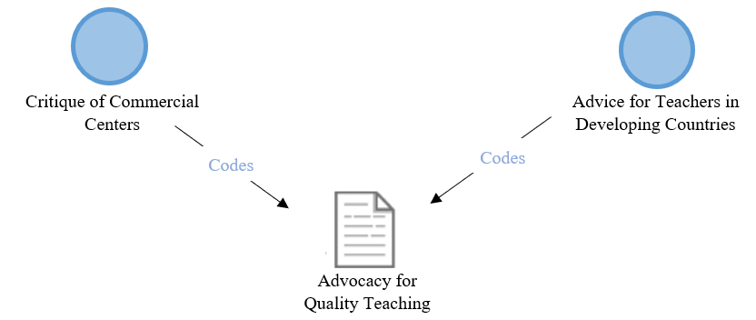
The teacher's advice and critique of the current English learning industry. Critique of Commercial Centers (Q6): "They're after your money. ... It's all about making money. All about making money. And without teaching it the correct way." Advice for Teachers in Developing Countries (Q12): "You need to have lots of patience. Patience. Let me see. Time. You've got to have your time. ... When children know that they're getting better and better and better, they want to become better and better." Finally, Mr. Tony offers a sharp critique of the commercial English learning industry, particularly centers that he claims are merely "after your money" without providing correct instruction. He warns that many paid centers do not employ native speakers or teach the "correct way," leading to a cycle of poor linguistic habits. His advice for teachers in developing countries centers on character and time management rather than just curriculum. He argues that educators "need to have lots of patience" and must give students the "time" they need to improve. According to his philosophy, when children perceive their own progress, it creates a self-sustaining desire to "become better and better."

DISCUSSION
The current research sets out to explore the role of teacher beliefs, intrinsic motivation, pedagogical practices, and sociocultural understanding in the effectiveness of online EFL instruction within the context of a voluntary and multicultural teaching situation. Unlike other studies that focus on the technological aspects of online instruction, this research attempts to shed light on the role of teacher cognition and relational practices in the effectiveness of online EFL instruction. The current research contributes to the existing body of knowledge by focusing on the human and pedagogical aspects of online EFL instruction in a non-commercial and learner-centered context. The findings of the current research reveal that the teacher’s long-term engagement in online EFL instruction is motivated by intrinsic and altruistic reasons, which the teacher expresses through emotional engagement with the learners and a complete rejection of financial compensation. This intrinsic motivation is not seen as separate from the teacher’s pedagogy but is closely intertwined with it. The second key finding of the current research reveals that the teacher’s pedagogy prioritizes intelligibility, fluency in reading, and pronunciation over grammatical accuracy. The third key finding of the current research reveals that the teacher exhibits adaptive problem-solving skills in the context of online instruction. The fourth key finding of the current research reveals that emotional safety and anxiety reduction play a key role in the instructional context. The significant role of intrinsic motivation is also consistent with the Self-Determination Theory that proposes that motivation for continued involvement is based on autonomy, competence, and relatedness (Bureau et al., 2022; Ryan & Deci, 2000). The satisfaction derived from the learners’ development is an example of competence fulfillment, and the continued involvement of the teacher in voluntary service is an example of autonomy fulfillment. Moreover, the social component of the teacher’s motivation is also consistent with the idea that teacher motivation is socially constructed and not an inherent trait of the teacher (Guay, 2022; Jeon & Lee, 2023). The feedback loop between the learners’ development and the teacher’s motivation is an example of this social construction of motivation. The emphasis on the teacher’s adaptation of instruction to the learners’ response patterns is also consistent with the literature on culturally responsive and context-sensitive instruction in online environments. Although the current study does not aim to make any generalizations about different cultures, the teacher’s sensitivity to the learners’ individual differences is consistent with the idea that learners’ preferences and participation styles are influenced by their sociocultural background and expectations about the teacher-student role relationships (Chen et al., 2021; Gan, 2021; Munandar & Newton, 2021). The current study’s findings support the need for adaptive instruction that is responsive to different learners’ readiness and involvement patterns in multicultural online classrooms (Anyichie & Butler, 2023; Jiang et al., 2021; Kumi-Yeboah, 2018).
The teacher’s critical perspective on the commercialization of language education is also consistent with the literature on the commodification of English language teaching and the role of English as a global language. The teacher’s emphasis on the learners’ confidence and communicative development over profit is consistent with critical perspectives on ELT that position it as part of global relations and market forces (Fairclough, 2001; Hopkyns et al., 2025; Karim et al., 2024). Although the current study does not explicitly draw on the decolonial perspective on language and language education, the emphasis on intelligibility and learners’ empowerment over native speaker models is consistent with the global Englishes and plurilingual perspectives on language and language education (Benjamin et al., 2022; Chaka & Ndlangamandla, 2022; Gutierrez & Aguirre Ortega, 2022). From the pedagogical point of view, the focus on the intelligibility of pronunciation and the reading rhythm, as opposed to grammatical accuracy, may be related to the research on the importance of comprehensibility as a realistic and rational goal of pronunciation instruction (Derwing, 2008; Saito, 2021). The teacher’s focus on word endings, pausing, and speech pacing may also reflect this focus on intelligibility. At the same time, the findings point to the experience-based nature of this instruction, as opposed to any phonetic training, which may also be linked to the need for professional development in the field of pronunciation instruction, as suggested by (Prahaladaiah & Andrew Thomas, 2024; Qaseem et al., 2024). The centrality of praise, patience, and emotional support may also be related to the importance of teacher dispositions as a means of promoting learner resilience and engagement. The emotional safety of the classroom has been linked to learners' willingness to take risks and engage with challenging material (Tu, 2021; Y. Wang et al., 2021). The fact that emotional support is not peripheral to the instructional process, as may be the case in some studies, may also point to its importance as a pedagogical tool, especially in the context of online instruction where the absence of physical presence may be more pronounced. One possible explanation for the centrality of intrinsic motivation may also be the voluntary nature of the instructional context. The fact that the teacher does not face any institutional barriers or financial incentives may point to the internalization of professional purpose and satisfaction as the source of the teacher’s engagement. While autonomous motivation has been described as the outcome of motivational beliefs (Bureau et al., 2022; Ryan & Deci, 2020), the findings of this study may point to the possibility that, in some contexts, pedagogy and motivation may be inseparable aspects of the teacher identity. The focus on intelligibility as opposed to grammar could be seen as a function of the teacher's commitment to communication in the real world, as opposed to the context of examinations. This is different from the findings in more formal EFL systems, where grammar accuracy is seen as closely linked to the structures of the assessment system. However, it is similar to research in the areas of communication and pronunciation, where the understanding of the listener is prioritized as opposed to the production of native speakers (Derwing, 2008; Saito, 2021), although this is in the context of implementation as opposed to the teacher's actual beliefs and practices.
The teacher's use of technology could be seen as need-driven as opposed to innovation-driven, as it does not seem to be aligned with the use of technology as a means to transform the institution, as seen in the majority of the research in this area. This is different from the majority of the research in this area, where the use of technology in online teaching is seen as being dependent on the design of the teaching, as opposed to the technology itself. The emphasis on emotional safety may also be related to the online context, where levels of anxiety may be exacerbated by physical distance. Although previous research indicates that affective support is an important aspect that should be considered positive (Pan et al., 2023; Y. Wang et al., 2021), it may be more central in virtual volunteer teaching when learner confidence is low and accountability is lacking. One of the differences with previous research on feedback is that there is little indication of correction, suggesting that confidence may have been prioritized more than accuracy. Finally, the teacher’s perspective on commercial ELT could be informed by her extensive experience outside the formal system. This approach contrasts with the research conducted within the formal system and aligns with the critical approach to the marketization of English language education (Fairclough, 2001; Hopkyns et al., 2025; Karim et al., 2024). However, the study is cautious not to assert that non-commercial contexts are superior; it argues that, in this case, the absence of a profit motive seems to be associated with a very learner-centric approach to teaching. The study suggests that the key to effective online EFL delivery lies in the interplay between intrinsic motivation, learner-centricity, emotional support, and the strategic deployment of technology. This study contributes to the existing literature by highlighting the application of these factors within a voluntary cross-cultural online EFL context.

CONCLUSION
This study shows that the teaching effectiveness of EFL in an online format in this particular context is closely associated with the teacher’s intrinsic motivation, pedagogical beliefs, emotional support approaches, and instructional adaptability, rather than the technology employed. The results of this study show that the teacher’s motivational commitment is associated with teaching patience, individual support, and building learners' confidence. The instructional priorities include learners' intelligibility, fluency in reading, and clear communication, and technology is used simply as a vehicle. Emotional safety is a pre-requisite for learners' participation, and instructional adaptability is consistently associated with learners' needs, rather than a set of procedures. Overall, these results portray online EFL teaching as a relational and belief-based practice, and teaching is characterized by constant responsiveness to learners. Several implications arise from this study. First, in relation to teacher preparation, this study shows that teacher preparation programs should place greater emphasis on teacher belief systems, motivational psychology, and affective classroom management, in addition to technology training. For instance, teacher preparation programs may benefit from incorporating training modules on teaching learners' pronunciation intelligibility, feedback, and reducing learners' anxiety in an online format. In relation to teaching practice, this study shows that online EFL teaching should include flexibility in materials, approaches, and interaction styles, in order to cater to learners' individual differences. Finally, in relation to policy, this study shows that policymakers should include a recognition of the relational and affective aspects of online teaching, which may not be captured in technology-based approaches. This study also has some limitations. The study is based on the experience of a single teacher in the context of volunteer teaching. The study, therefore, does not reflect the general context of online EFL teaching. The study also focuses on the opinions of the teacher, which are collected through interviews. The opinions of the teacher may not reflect the real-life classroom experience of the teacher. The cross-cultural dimension of the study also focuses on the opinions of the teacher. The opinions of the teacher may not reflect the opinions of the learners.Future research on this topic could focus on the experience of multiple teachers in multiple contexts to compare the patterns of motivation and teaching. The experience of the teacher could also be observed through multiple methods of data collection, including the opinions of the learners. The differences between the volunteer teaching context and the commercial teaching context could also be explored to understand the role of the environment on the motivation of the teacher. The professional development of the teacher could also be explored as a way of understanding the role of teacher cognition in the context of online EFL education.

REFERENCES
Anyichie, A. C., & Butler, D. L. (2023). Examining culturally diverse learners’ motivation and engagement processes as situated in the context of a complex task. Frontiers in Education, 8. https://doi.org/10.3389/feduc.2023.1041946
Arellano, E. L., Barcenal, T. L., Bilbao, P. P., Castellano, M. A., Nichols, S., & Tippins, D. J. (2001). Case‐based pedagogy as a context for collaborative inquiry in the Philippines. Journal of Research in Science Teaching, 38(5), 502–528. https://doi.org/10.1002/tea.1016
Bandara, W., Furtmueller, E., Gorbacheva, E., Miskon, S., & Beekhuyzen, J. (2015). Achieving Rigor in Literature Reviews: Insights from Qualitative Data Analysis and Tool-Support. Communications of the Association for Information Systems, 37. https://doi.org/10.17705/1CAIS.03708
Benjamin, I., Figueira, J. V, Miquilarena, R., Rodriguez, F., Lopez, A., & Lerner, J. (2022). Ectopic pregnancy with a contralateral corpus luteum: Case report. JBRA Assisted Reproduction. https://doi.org/10.5935/1518-0557.20220050
Blignaut, A. S., Hinostroza, J. E., Els, C. J., & Brun, M. (2010). ICT in education policy and practice in developing countries: South Africa and Chile compared through SITES 2006. Computers & Education, 55(4), 1552–1563. https://doi.org/10.1016/j.compedu.2010.06.021
Bryda, G., & Costa, A. P. (2023). Qualitative Research in Digital Era: Innovations, Methodologies and Collaborations. Social Sciences, 12(10), 570. https://doi.org/10.3390/socsci12100570
Bureau, J. S., Howard, J. L., Chong, J. X. Y., & Guay, F. (2022). Pathways to Student Motivation: A Meta-Analysis of Antecedents of Autonomous and Controlled Motivations. Review of Educational Research, 92(1), 46–72. https://doi.org/10.3102/00346543211042426
Cementina, S. (2019). Language Teachers’ Digital Mindsets: Links Between Everyday Use and Professional Use of Technology. TESL Canada Journal, 36(3), 31–54. https://doi.org/10.18806/tesl.v36i3.1320
Chaka, C., & Ndlangamandla, S. (2022). Relocating English Studies and SoTL in the Global South: Towards Decolonizing English and Critiquing the Coloniality of Language. Journal of Contemporary Issues in Education, 17(2), 39–56. https://doi.org/10.20355/jcie29495
Chen, Y., Chuang, H.-H., & Lacaste, A. (2021). A pedagogical framework of cross-cultural online collaborative projects in English as Foreign Language (EFL) classrooms. Journal of Education and Learning (EduLearn), 15(2), 223–233. https://doi.org/10.11591/edulearn.v15i2.19950
Cheng, K.-H., & Tsai, C.-C. (2019). A case study of immersive virtual field trips in an elementary classroom: Students’ learning experience and teacher-student interaction behaviors. Computers & Education, 140, 103600. https://doi.org/10.1016/j.compedu.2019.103600
Derwing, T. M. (2008). 13. Curriculum issues in teaching pronunciation to second language learners (pp. 347–369). https://doi.org/10.1075/sibil.36.17der
Fairclough, N. (2001). Language and Power. Longman.
Feng, X., & Behar-Horenstein, L. (2019). Maximizing NVivo utilities to analyze open-ended responses. The Qualitative Report, 24(3), 563–571.
Fenyi, D. A., Andoh, J., & Mensah, E. A. (2020). E-Language Pedagogy the Go-to? Attitude of the College language tutor towards Technology Integration. Journal of Education and Practice. https://doi.org/10.7176/JEP/11-30-14
Gan, S. (2021). The Role of Teacher-Student Relatedness and Teachers’ Engagement on Students’ Engagement in EFL Classrooms. Frontiers in Psychology, 12. https://doi.org/10.3389/fpsyg.2021.745435
Guay, F. (2022). Applying Self-Determination Theory to Education: Regulations Types, Psychological Needs, and Autonomy Supporting Behaviors. Canadian Journal of School Psychology, 37(1), 75–92. https://doi.org/10.1177/08295735211055355
Gutierrez, C. P., & Aguirre Ortega, M. (2022). English Instructors Navigating Decoloniality with Afro Colombian and Indigenous University Students. Íkala, Revista de Lenguaje y Cultura, 27(3), 783–802. https://doi.org/10.17533/udea.ikala.v27n3a11
Hambira, N., Lim, C. K., & Tan, K. L. (2017). Emotional and cultural impacts of ICT on learners: A case study of Opuwo, Namibia. 020048. https://doi.org/10.1063/1.5005381
Hasanah, N., & Abdulrahman, T. R. (2021). E-Learning And Efl Teachers’ Intercultural Competence: An Analysis Of Benefits And Challenges. Akademika, 10(01), 197–217. https://doi.org/10.34005/akademika.v10i01.1323
Hidson, E. (2020). Internet Video Calling and Desktop Sharing (vcds) as an Emerging Research Method for Exploring Pedagogical Reasoning in Lesson Planning. Video Journal of Education and Pedagogy, 5(1), 1–14. https://doi.org/10.1163/23644583-00501001
Hopkyns, S., Dovchin, S., & Sultana, S. (2025). The politics of distraction in English-medium higher education across three global settings: a collaborative autoethnography. Current Issues in Language Planning, 26(3), 371–391. https://doi.org/10.1080/14664208.2024.2358692
Hur, J. W., Shen, Y. W., & Cho, M.-H. (2020). Impact of intercultural online collaboration project for pre-service teachers. Technology, Pedagogy and Education, 29(1), 1–17. https://doi.org/10.1080/1475939X.2020.1716841
Jeon, J., & Lee, S. (2023). Teachers’ use of motivational strategies in the synchronous online environment: A self-determination theory perspective. Education and Information Technologies, 28(9), 11963–11986. https://doi.org/10.1007/s10639-023-11656-1
Jiang, Q., Soon, S., & Li, Y. (2021). Enhancing Teachers’ Intercultural Competence with Online Technology as Cognitive Tools: A Literature Review. English Language Teaching, 14(3), 1. https://doi.org/10.5539/elt.v14n3p1
Karim, A., Kabilan, M. K., Sultana, S., Amin, E. U., & Rahman, M. M. (2024). Reflecting on Reflections Concerning Critical Incidents in Developing Pre-Service Teachers’ Professional Identity: Evidence from a TESOL Education Project. English Teaching & Learning, 48(3), 291–318. https://doi.org/10.1007/s42321-023-00140-1
Kerwin-Boudreau, S., & Butler-Kisber, L. (2016). Deepening Understanding in Qualitative Inquiry. The Qualitative Report. https://doi.org/10.46743/2160-3715/2016.2623
Kumi-Yeboah, A. (2018). Designing a cross-cultural collaborative online learning framework for online instructors. Online Learning, 22(4), 181–201.
Kuru Gönen, S. İ. (2019). A qualitative study on a situated experience of technology integration: reflections from pre-service teachers and students. Computer Assisted Language Learning, 32(3), 163–189. https://doi.org/10.1080/09588221.2018.1552974
Kuş Saillard, E. (2011). Systematic versus interpretive analysis with two CAQDAS packages: NVivo and MAXQDA. Forum Qualitative Sozialforschung / Forum: Qualitative Social Research, 12.
Li, F., Zeng, Y., Fu, Y., Wang, Y., Lin, T., Deng, Q., & Li, J. (2024). Stressors and coping styles of nursing students in the middle period of clinical practicum: a qualitative study. BMC Nursing, 23(1), 394. https://doi.org/10.1186/s12912-024-02063-z
Maher, C., Hadfield, M., Hutchings, M., & de Eyto, A. (2018). Ensuring Rigor in Qualitative Data Analysis. International Journal of Qualitative Methods, 17(1). https://doi.org/10.1177/1609406918786362
Maru, M. G., Pikirang, C. C., Ratu, D. M., & Tuna, J. R. (2021). The Integration of ICT in ELT Practices: The Study on Teachers’ Perspective in New Normal Era. International Journal of Interactive Mobile Technologies (IJIM), 15(22), 44–67. https://doi.org/10.3991/ijim.v15i22.25533
Moorhouse, B. L., Walsh, S., Li, Y., & Wong, L. L. C. (2022). Assisting and Mediating Interaction during Synchronous Online Language Lessons: Teachers’ Professional Practices. TESOL Quarterly, 56(3), 934–960. https://doi.org/10.1002/tesq.3144
Munandar, M. I., & Newton, J. (2021). Indonesian EFL teachers’ pedagogic beliefs and classroom practices regarding culture and interculturality. Language and Intercultural Communication, 21(2), 158–173. https://doi.org/10.1080/14708477.2020.1867155
Ngo, D. H. (2022). Exploring EFL undergraduates’ views of the impact teachers have on their online learning engagement during the COVID-19 pandemic in Vietnam. International Journal of TESOL & Education, 2(3), 75–95. https://doi.org/10.54855/ijte.22236
Nguyen, N., & Williams, P. J. (2016). An ICT supported sociocultural approach to improve the teaching of physics. Asia-Pacific Science Education, 2(1), 2. https://doi.org/10.1186/s41029-016-0008-2
Nguyen, T. P. D., & Nguyen, V. L. (2020). EMI in Vietnam: What High School Teachers Think and Do. International Journal of Language Teaching and Education, 4(1), 36–52. https://doi.org/10.22437/ijolte.v4i1.8754
Omona, J. (2013). Sampling in Qualitative Research: Improving the Quality of Research Outcomes in Higher Education. Makerere Journal of Higher Education, 4(2). https://doi.org/10.4314/majohe.v4i2.4
Palys, T., & Atchison, C. (2012). Qualitative Research in the Digital Era: Obstacles and Opportunities. International Journal of Qualitative Methods, 11(4), 352–367. https://doi.org/10.1177/160940691201100404
Pan, Z., Wang, Y., & Derakhshan, A. (2023). Unpacking Chinese EFL Students’ Academic Engagement and Psychological Well-Being: The Roles of Language Teachers’ Affective Scaffolding. Journal of Psycholinguistic Research, 52(5), 1799–1819. https://doi.org/10.1007/s10936-023-09974-z
Peng, R., Abdul Razak, R., & Hajar Halili, S. (2023). Factors influencing in-service teachers’ technology integration model: Innovative strategies for educational technology. PLOS ONE, 18(8), e0286112. https://doi.org/10.1371/journal.pone.0286112
Pham, T. T. H., & Renshaw, P. (2015). Adapting evidence-based pedagogy to local cultural contexts: a design research study of policy borrowing in Vietnam. Pedagogies: An International Journal, 10(3), 256–274. https://doi.org/10.1080/1554480X.2015.1009836
Phillips, H. N. (2021). Re-imagining higher education: A cohort of teachers’ experiences to face the ‘new normal’ during COVID19. International Journal of Educational Research Open, 2, 100069. https://doi.org/10.1016/j.ijedro.2021.100069
Phuong, H. T. T. (2020). Gamified Learning: Are Vietnamese EFL Learners Ready Yet? International Journal of Emerging Technologies in Learning (IJET), 15(24), 242. https://doi.org/10.3991/ijet.v15i24.16667
Poth, C. (2018). The contributions of mixed insights to advancing technology-enhanced formative assessments within higher education learning environments: an illustrative example. International Journal of Educational Technology in Higher Education, 15(1), 9. https://doi.org/10.1186/s41239-018-0090-5
Prahaladaiah, D., & Andrew Thomas, K. (2024). Effect of phonological and phonetic interventions on proficiency in English pronunciation and oral reading. Education Research International, 2024(1), 9087087.
Qaseem, S., Babar, M., Khalid, M., & Yousuf, M. I. (2024). Managing Classroom Practices Involved in English Pronunciation Instruction. Qlantic Journal of Social Sciences and Humanities, 5(3), 33–44. https://doi.org/10.55737/qjssh.363997487
Russell, M., Bebell, D., O’Dwyer, L., & O’Connor, K. (2003). Examining Teacher Technology Use. Journal of Teacher Education, 54(4), 297–310. https://doi.org/10.1177/0022487103255985
Ryan, R. M., & Deci, E. L. (2000). Self-determination theory and the facilitation of intrinsic motivation, social development, and well-being. American Psychologist, 55(1), 68–78. https://doi.org/10.1037/0003-066X.55.1.68
Ryan, R. M., & Deci, E. L. (2020). Intrinsic and extrinsic motivation from a self-determination theory perspective: Definitions, theory, practices, and future directions. Contemporary Educational Psychology, 61, 101860. https://doi.org/10.1016/j.cedpsych.2020.101860
Saito, K. (2021). What Characterizes Comprehensible and Native‐like Pronunciation Among English‐as‐a‐Second‐Language Speakers? Meta‐Analyses of Phonological, Rater, and Instructional Factors. TESOL Quarterly, 55(3), 866–900. https://doi.org/10.1002/tesq.3027
Sim, J. S. E., & Ismail, H. H. (2023). Using Digital Tools in Teaching and Learning English: Delving into English Language Teachers’ Perspectives. Creative Education, 14(10), 2021–2036. https://doi.org/10.4236/ce.2023.1410129
Tao, J., & Gao, X. (2022). Teaching and learning languages online: Challenges and responses. System, 107, 102819. https://doi.org/10.1016/j.system.2022.102819
Tu, X. (2021). The Role of Classroom Culture and Psychological Safety in EFL Students’ Engagement. Frontiers in Psychology, 12. https://doi.org/10.3389/fpsyg.2021.760903
Waluyo, B., & Apridayani, A. (2021). Teachers’ beliefs and classroom practices on the use of video in English language teaching. Studies in English Language and Education, 8(2), 726–744. https://doi.org/10.24815/siele.v8i2.19214
Wang, P. (2022). Relooking at the Roles of Translanguaging in English as a Foreign Language Classes for Multilingual Learners: Practices and Implications. Frontiers in Psychology, 13. https://doi.org/10.3389/fpsyg.2022.850649
Wang, Y., Derakhshan, A., & Zhang, L. J. (2021). Researching and Practicing Positive Psychology in Second/Foreign Language Learning and Teaching: The Past, Current Status and Future Directions. Frontiers in Psychology, 12. https://doi.org/10.3389/fpsyg.2021.731721
Welsh, E. (2002). Dealing with Data: Using NVivo in the Qualitative Data Analysis Process. Forum: Qualitative Social Research, 3.
Wong, L. P. (2008). Data Analysis in Qualitative Research: A Brief Guide to Using Nvivo. Malaysian Family Physician, 3.
Yuan, R., & Yang, M. (2023). Towards an understanding of translanguaging in EMI teacher education classrooms. Language Teaching Research, 27(4), 884–906. https://doi.org/10.1177/1362168820964123
Zhang, Z., & Martinovic, D. (2009). ICT in teacher education: Examining needs, expectations and attitudes. Canadian Journal of Learning and Technology / La Revue Canadienne de l’apprentissage et de La Technologie, 34(2). https://doi.org/10.21432/T2WK5T

